Trade of Metal Fabrication
Module 3: | Plate Fabrication
Unit 6: | Square Tank
 | Phase 2

Table of Contents
List of Figures 5
List of Tables 5
Document Release History 6
Module 3 – Plate Fabrication 7
Unit 6 – Square Tank 7
Learning Outcome: 7
Key Learning Points: 7
Training Resources: 7
Key Learning Points Code: 7
VI-Air Compressors 8
Introduction 8
Setting the Guillotine 13
Operations on the Guillotine 14
Combustion 16
Combustion or Burning 16
The Oxy-Acetylene Welding Flame 16
Corrosion 18
Two Kinds of Corrosion 18
Oxidation (Chemical Corrosion) 18
Electro-Chemical Corrosion 18
Examples of Electro-Chemical Corrosion 18
Bright Strips on Cars 18
The Rusting of Iron 20
Oxidation 20
Reduction or Deoxidation 21
Reduction 22
A) The “Tinplate Case” 22
B) Protection against Corrosion 22
C) Corrosion Resistance 22
Copper 23
Anodising 24
Corrosion Resistance of Steel 24
Protective Coatings 24
Painting 24
Hot Dipping 25
Metal Stripping 25
Electro-Plating 26
Self Assessment 27
Answers to Questions 1-3. Module3.Unit 6 28
Index 30

List of Figures
Figure 1 - Piston Compressor 9
Figure 2 - Two Stage Compressor 10
Figure 3 - "V" Type Compressor 10
Figure 4 - Principal Air Compressor Components 12
Figure 5 - Front and Side Gauges (Guillotines) 14
Figure 6 - Bright Strips on Cars 19
Figure 7 - Effects of Stainless Steel Trim on a Steel Car Body 19
Figure 8 - Rusting of Iron 20
Figure 9 - Reduction 23
Figure 10 - Anodising 24
Figure 11 - Metal spraying 25
Figure 12 - Electro-Plating 26

List of Tables

Document Release History
Date | Version | Comments
15/12/06 | First draft
13/12/13 | SOLAS transfer

Module 3 – Plate Fabrication

Unit 6 – Square Tank
Duration – 7 Hours

Learning Outcome:
By the end of this unit each apprentice will be able to:
- Read and interpret drawing
- Mark out and shear plate and flat bar, thread G.B. pipe, assemble, weld and test a tank

Key Learning Points:
Rk Sk | Safe operation of guillotine.
Sk | Blade adjustment – setting back gauge.
Sk | Assembly procedures.
Sk | Baffles – where they are used and why.
Sk | Manual Arc Welding – electrode selection and current settings.
Sk | Threading of pipe.
Rk Sk | Low pressure testing of tanks.
Sk | Flame cutting with step down nozzles.
H | Safety when using compressed air.
Sc | Oxidation, reduction and combustion.
P | Ability, initiative, standard of work.

Training Resources:

- Fabrication workshop
- Shears
- Bandsaw
- Manual metal arc
- Plant and consumables
- Apprentice tool kit
- Safety clothing and equipment
- Stocks and dies
- Compressed air test facilities

Key Learning Points Code:
M = Maths D= Drawing RK = Related Knowledge Sc = Science
P = Personal Skills Sk = Skill H = Hazards

VI-Air Compressors

Introduction
All air tools, spray guns, sanders, etc., must be supplied with air which is elevated to the correct pressure and volume. This is one function of an air compressor. The air compressor is the major component of a spray painting system. This chapter will explain what a compressor does and how it does it, and will examine the various types available. It will also provide information on the proper selection of a compressor, installation, maintenance and troubleshooting.

What is an air Compressor?
An air compressor is a machine designed to raise the pressure of air from normal atmospheric to some higher pressure, as measured in pounds per square inch (psi). While normal atmospheric pressure is about 14.7 pounds per square inch, a compressor will typically deliver air at pressures up to 200 psi.

What types of compressors are most common in spray finishing operations?
There are two common types: the piston-type design and the diaphragm-type design. Because most commercial spray finishing operations consume large quantities of compressed air at relatively high pressures, the piston-type compressor is much more common in these situations.

How does a Piston-type Compressor work?
As shown in Figure 1, this design elevates the incoming air pressure through the action of a reciprocating piston. As the piston moves down, air is drawn in through an intake valve, the piston travels upward and compresses the air, and then the now compressed air is discharged through an exhaust valve to an air line. Piston compressors are available in single or multiple cylinder and single or two-stage models, depending on the volume and pressure required. This is the type of compressor usually found in a professional finishing operation.
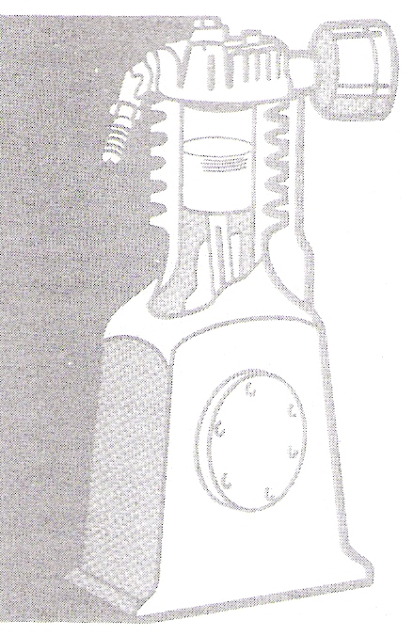
Figure 1 - Piston Compressor

How does a Diaphragm-type Compressor work?
This type design, which is usually quite small in volume and pressure, develops pressure through the reciprocating action of a flexible disk actuated by an eccentric.

What is a Single Stage Compressor?
This is a piston-type compressor with one or more cylinders in which air is drawn from the atmosphere and compressed to its final pressure with a single stroke. Figure 1 shows a single stage compressor.

Where are Single Stage Compressors used?
The application of this type is usually limited to maximum pressures of 100 psi or less. They can be used above 100 psi, but they are not as efficient as two stage compressors.

What is a Two Stage Compressor?
A compressor with two or more cylinders of unequal size in which air is compressed in two separate steps, as shown in Figure 2. The first or largest cylinder compresses the air to an intermediate pressure and then exhausts it into a connecting tube called an intercooler. From there the intermediate pressure air enters the smaller cylinder where it is compressed to an even higher pressure and delivered to a storage tank or the main air fine.
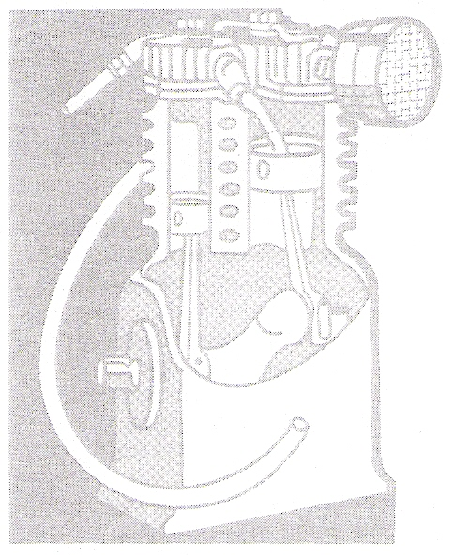
Figure 2 - Two Stage Compressor

Where are Two Stage Compressors used?
They are normally found in operations requiring compressed air of 100 psi or greater.

What are the benefits of Two Stage Compressors?
Two stage compressors are usually more efficient, run cooler, and deliver more air for the power consumed, particularly in the over-100 psi pressure range.

What is a "V "-type Compressor?
As illustrated in Figure 3, this is a compressor with two or more cylinder arranged at an angle to the crankcase which forms a "V". This type is occasionally called a "Y" type.
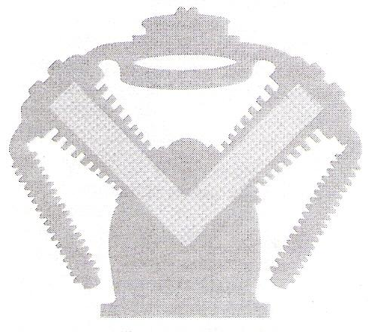
Figure 3 - "V" Type Compressor
What is an Upright Type Compressor?
This is a single or two stage compressor with the piston(s) travelling vertically. Figure 2 shows an upright compressor.

What is meant by "displacement" of a compressor?
This is the theoretical or calculated volume of air the cylinder(s) discharge, measured in cubic feet per minute (cfm). It makes no allowance for heat, friction or other losses in the compressing cycle. The displacement of a two stage compressor is always given for the first stage cylinder(s) only. This is because the second stage merely rehandles the same air the first stage draws in, and does not increase the amount of air discharged.

How is displacement computed?
By the following formula:
Area of cylinder x Length of Stroke x R.P.M. = Displacement in cubic inches.
To change the cubic inches to cubic feet, divide the sum by 1728 (the cubic inches in a cubic foot). The formula for computing it is as follows:

Both bore and stroke measurements in the above formula should be in inches. The above formula applies to single stage compressors, but can be used for two stage units since the small high pressure cylinder or cylinders are not computed.

What is meant by the "delivery" of a compressor?
This is the actual amount of air delivered by the compressor, stated in cfm (cubic feet per minute). This can be actually measured or computed by multiplying the displacement by the volumetric efficiency, if it is known. For example, a single stage compressor (for 100 lb. service) with a displacement of 10 cfm and 70% volumetric efficiency would actually deliver about 7 cfm.

What is meant by the "volumetric efficiency" of a compressor?
This is the ratio of air actually delivered to air displaced.
What is the average volumetric efficiency of a single stage compressor?
Maximum Working Pressure
75 lbs. | 75 %
60 lbs. | 70 %
125 lbs. | 65 %
150 lbs. | 60 %

What is the average volumetric efficiency of a two stage compressor?
Maximum Working Pressure
100 lbs. | 80 %
125 lbs. | 80 %
150 lbs. | 80 %
175 lbs. | 80 %

What are the principal parts of a piston type compressor?
As shown in Figure 4, they are
(A) intake and (B) exhaust valves; (C) cylinder; (D) crankcase; (E) crankshaft; (F) piston and (G) connecting rod assembly; and (H) air intake filter.
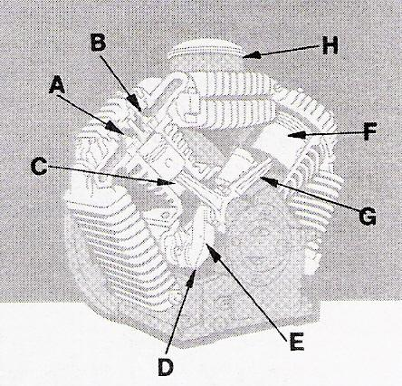
Figure 4 - Principal Air Compressor Components

What features should a good air compressor have?
Although a small, hobby type compressor may not have all of the following features, it should have most of them. A professional compressor should be designed with all of the following: a) Easily removable valve assemblies.

Setting the Guillotine
Treadle and power guillotines are fitted with FRONT and SIDE GAUGES. These usually consist of a FIXED SIDE GAUGE, sometimes referred to as the 'SQUARING GUIDE', and a FLAT BAR FRONT GAUGE.

On some machines the side gauge can be extended for wide sheets, and may be graduated in millimetres.

The front gauge is adjustable across the bed or table, and further along extension bars (arms fitted to the front of the machine). Figure 5(a) shows a plan view of the side and front gauges. Figure 5(b) and Figure 5(c) show how the gauges are set.

The bulk of cutting performed on the guillotine is when the sheet or plate is located against a BACK GAUGE, and there are several types of these. The simplest, and usual standard type, consists of an ANGLE GAUGE BAR. Back gauges are mounted on an attachment fixed to the movable cutting beam and move up and down with it. Figure 5 gives basic details of gauges and guides used on guillotines.

Where precision cutting is required, the simple back gauge will take a while to set in order to achieve the exact size register.

On batch or bulk cutting operations where the back gauge has to be moved constantly a more elaborate type of back gauge is necessary to enable the settings to be carried out more quickly, reducing both the actual time taken to move the gauge and then the time to set it to a dead size.

Even the simple type of back gauge can have an attachment for final fine adjustment, as shown in Figure 5. The guide is set in an approximate position and locking lever B tightened. The final setting to correct register is achieved by slackening lever A, and turning the hand wheel on the fine adjustment screw. The back gauge is then locked in position by tightening locking lever A.

Operations on the Guillotine
The fixed side gauge is used for positioning the material. To square off two adjacent sides of a sheet or plate, a trim-cut of approximately 6 mm is made on one edge. The second edge is then sheared at 90° to the first by holding the trimmed edge firmly against the side gauge which is normally located on the left-hand side of the table.
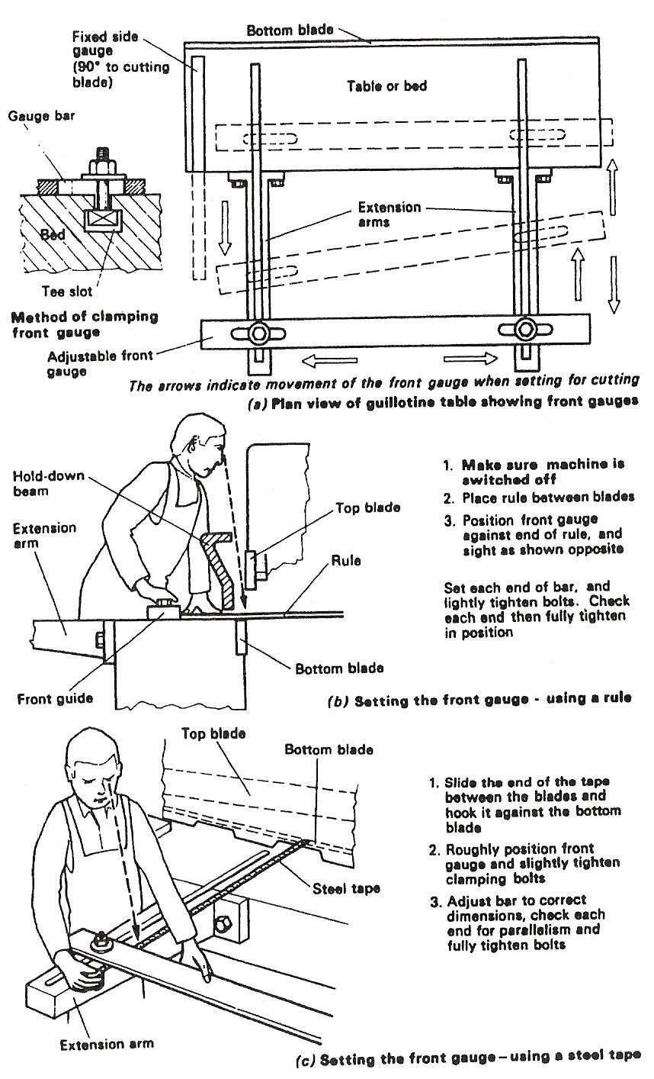
Figure 5 - Front and Side Gauges (Guillotines)
There are two main types of guillotines:

- Mechanical
- Hydraulic

Three main factors that effect the safe operation of a guillotine:

- Brake clearance
- Rake angle
- Relief angle

Know where the emergency stop is located.

Make sure no person is standing at the back of the machine.

Keep hands clear when holding down clamps grip plate is being cut.

Combustion
Basically, there are three things necessary for combustion to take place:

  - Fuel
  - Oxygen
  - Source of ignition

The following pages explain combustion in more detail.

Combustion or Burning
The study of combustion is very closely associated with the properties of oxygen. When burning takes place, a chemical action occurs. If a flame is formed, the reaction is so vigorous that the gases become luminous. Hydrogen burns in air with a blue, non-luminous flame to water. In the oxy-hydrogen flame, hydrogen is burnt in a stream. This causes intense heat to be developed, with a flame temperature of about 2800°C.

The oxy-coal-gas flame is very similar, as the coal gas consists hydrogen, together with other impurities (methane, carbon monoxide and other hydrocarbons). Because of these impurities, the temperature of this flame is much lower than when pure hydrogen is used. The oxy-acetylene flame consists of the burning of acetylene in a stream of oxygen. Acetylene is composed of car bon and hydrogen (C2 H2), and it is a gas which burns in air with a very smoky flame, the smoke being due, as in the case of a candle, to incomplete combustion of the carbon:

acetylene + oxygen carbon + water
2 C2 H2 + 02 4C + 2 H2O.

By using, however, a special kind of burner, we have almost complete combustion and the acetylene burns with a very brilliant flame, due to the incandescent carbon.

The Oxy-Acetylene Welding Flame
When oxygen is mixed with the acetylene in approximately equal proportions a blue, non-luminous flame is produced, the most brilliant part being the blue cone at the centre. The temperature of this flame is given, with others, in the table:
Temperatures of various flames
Oxy-acetylene 3100°C
Oxy-butane (Calor-gas) 2820°C
Oxy-propane (liquefied petroleum gas, LPG) 2815°C
Oxy-methane (natural gas) 2770°C
Oxy-hydrogen 2825°C
Air-acetylene 2325°C
Air-methane 1850°C
Air-propane 1900°C
Air-butane 1800°C
(Metal arc: 6000 DC upwards depending on type of arc)

This process of combustion occurs in two stages: (1) in the innermost blue, luminous cone; (2) in the outer envelope. In (1) the acetylene combines with the oxygen supplied, to form carbon monoxide and hydrogen:
acetylene + oxygen carbon monoxide + hydrogen
C2H2 + 02 2CO + H2.

In (2) the carbon monoxide burns and forms carbon dioxide, while the hydrogen which is formed from the above action combines with oxygen to form water:

carbon monoxide + hydrogen + oxygen carbon dioxide + water
CO + H2 + 02 CO2 + H2O.

The combustion is therefore complete and carbon dioxide and water (turned to steam) are the chief products of the combustion. If insufficient oxygen is supplied, the combustion will be incomplete and carbon will be formed.
From this it will be seen that the oxy-acetylene flame is a strong reducing agent, since it absorbs oxygen from the air in the outer envelope. Much of its success as a welding flame is due to this, as the tendency to form oxides is greatly decreased. For complete combustion, there is a correct amount of oxygen for a given amount of acetylene. If too little oxygen is supplied, combustion is incomplete and carbon is set free. This is known as a carbonising or carburising flame. If too much oxygen is supplied, there is more than is required for complete combustion, and the flame is said to be an oxidising flame.
For usual welding purposes the neutral flame, that is neither carbonising nor oxidising, is required, combustion being just complete with excess of neither carbon nor oxygen. For special work an oxidising or carbonising flame may be required, and this is always clearly indicated.

Corrosion
Many of the things used by us are made from mild steel. It is the most commonly used engineering material, but it has one major drawback, and that is that it rusts. Rust is the arch enemy of the car owner! One hears of steel bridges which have to be painted continuously (i.e. when the painters have finished, they just start again) to keep the 'rogue' rust at bay! Other metals corrode too, but we will pay most attention to mild steel.

Two Kinds of Corrosion

Oxidation (Chemical Corrosion)
Metals have a chemical attraction for oxygen. When moisture is present, the metals can combine with oxygen in the atmosphere to form surface oxides. In the case of mild steel, the oxide formed is red and is known as rust. The process is speeded up if the atmosphere is polluted. When sulphur bearing fuels are burned, sulphur dioxide is formed and this contributes a lot to the corrosion of steel.

Electro-Chemical Corrosion
When two different metals (e.g. copper and zinc) are placed in a jar of electrolyte (e.g. dilute sulphuric acid or salt water), an electric current will be produced). This current is caused by electro-chemical action.
This same electro-chemical action can cause corrosion if two different metals are touching and there is water present. The simple cell is set up with the water acting as the electrolyte. One of the two metals will be 'eaten' away or corroded.

Examples of Electro-Chemical Corrosion
You should now know why it is a bad idea to have two different metals in contact with an electrolyte present. Moisture in the atmosphere or rain can both act as electrolytes.

Bright Strips on Cars
Bright strips of metal can add to the appearance of the family car, but they sometimes cause corrosion. Stainless steel is an example of a metal used for these 'decorative strips' or 'trims'. Supposing the paint under a stainless steel trim chips off; then the trim will be in contact with the mild steel body of the car. To set up electrolytic action, all that is needed is a shower of rain or some condensation.
So, it is not unusual to see corrosion under these trims.
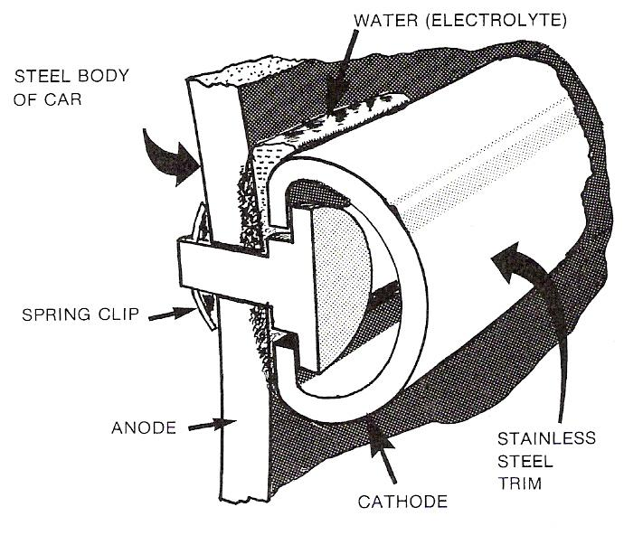
Figure 6 - Bright Strips on Cars

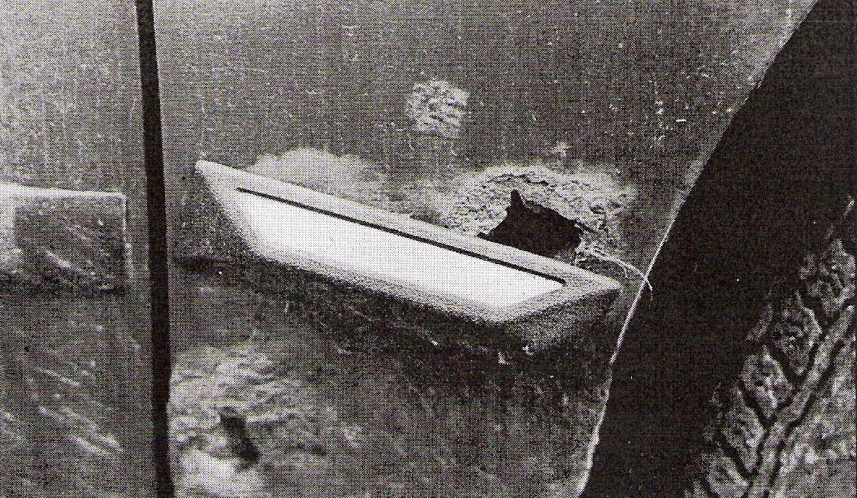
Figure 7 - Effects of Stainless Steel Trim on a Steel Car Body

The Rusting of Iron
Moisten the inside of a glass jar so that small iron filings will adhere to the interior surface and invert the jar over a bowl of water, thus entrapping some air inside the jar (Figure 8).
If the surface of the water inside the jar is observed, it is seen that as time passes and the iron filings become rusty, the surface of the water rises and eventually remains stationary at a point roughly 1/5 of the way up the jar. From the similar experiment performed with the burning candle it can be seen that the oxygen has been used up as the iron rusts and nitrogen remains in the jar. The rusting iron is, therefore, a process of surface oxidation.
This can further be demonstrated as follows: boil some water for some time in a glass tube (or test tube) in order to expel any dissolved oxygen, and then place a brightly polished nail in the water. Seal the open end of the tube by pouring melted Vaseline down onto the surface of the water. The nail will now keep bright indefinitely, since it is completely out of contact with oxygen.
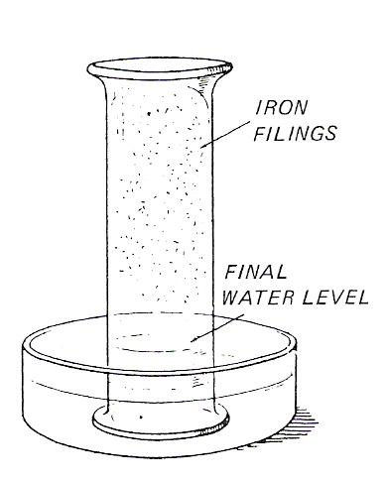
Figure 8 - Rusting of Iron

Oxidation
Oxygen reacts with metals in various ways, depending on:
- The character of the metal. Magnesium burns very completely to form magnesium oxide, while copper, aluminium and chromium form a protective oxide film on their surface at room temperature.
- Temperature. Zinc at normal temperature only oxidises slowly on the surface, but if heated to high temperature it burns with a bright bluish-white flame, forming a white powder, zinc oxide. Nearly all base metals can be converted to their oxide by heating them in oxygen.
- The amount of surface exposed. The larger the surface area the greater the amount of oxidation.
- The amount of oxygen present. Oxidation is much more rapid, for example, in a stream of pure oxygen than in air.
- Presence of other substances. Iron will not rust if no water is present.

Reduction or Deoxidation
Reduction takes place when oxygen is removed from a substance. Evidently it is always accompanied by oxidation, since the substance that removes the oxygen will become oxidised.
The great affinity of aluminium for oxygen is made use of in the thermit process of welding and provides an excellent example of chemical reduction.

Examples of:

Oxidising agents
(1) Oxygen
(2) Ozone
(3) Nitric acid
(4) Chlorine
(5) Potassium chlorate
(6) Potassium nitrate
(7) Manganese dioxide
(8) Hydrogen peroxide
(9) Potassium permanganate

Reducing agents
(1) Hydrogen
(2) Carbon
(3) Carbon monoxide
(4) Sulphur dioxide (at low temperatures)
(5) Sulphuretted hydrogen
(6) Zinc dust
(7) Aluminium

Reduction

A) The “Tinplate Case”
Tinplate is thin sheet steel covered with a coating of tin. It is widely used in the tinned food industry.
The tin is only a mechanical protection for the steel because, if any of the tin coat is removed, electrolytic action can start. Again, all that is needed is moisture and the steel will corrode.

B) Protection against Corrosion
This is where one metal is 'sacrificed' to save another from corrosion. One of the best examples of this is the protection of propellers on boats. Most propellers on trawlers are made from bronze. Sea water attacks and corrodes the bronze propellers which are very expensive to replace.
So, a slab of zinc is screwed to the wooden hull near the propeller and is made the anode in the electro-chemical action. The propeller is the cathode (cathodic protection). Galvanised iron is another example where the zinc coating offers mechanical protection, and also will provide sacrificial protection if some of the zinc is scraped away.

C) Corrosion Resistance
Some metals are very resistant to corrosion. This is because they form strong oxides on their surfaces.
If you cut or scrape a piece of lead with a knife, you will notice that the surface is very shiny. When this is left for some time, a dull grey oxide forms which protects the lead from oxidation.
Aluminium, copper, and zinc are three other metals which have high resistance to corrosion in the same way that lead has.

Copper
Copper is extremely resistant to atmospheric corrosion, since it forms a film of oxide on its surface. This film is very unlike rust on iron, because it protects the metal and offers high resistance to any further attack. In time the oxide becomes changed to compounds having a familiar green colour such as sulphate of copper. When copper is brightly polished and exposed to a clean, dry atmosphere it tarnishes and becomes coated with a thin film of cuprous oxide (Cu2O). If the temperature of the copper is now raised, the amount of oxidation increases proportionally and at high temperatures the copper begins to scale. The black scale formed is cupric oxide (CuO), while underneath this is another film of cuprous oxide (Cu2O), which has a characteristic red colour.

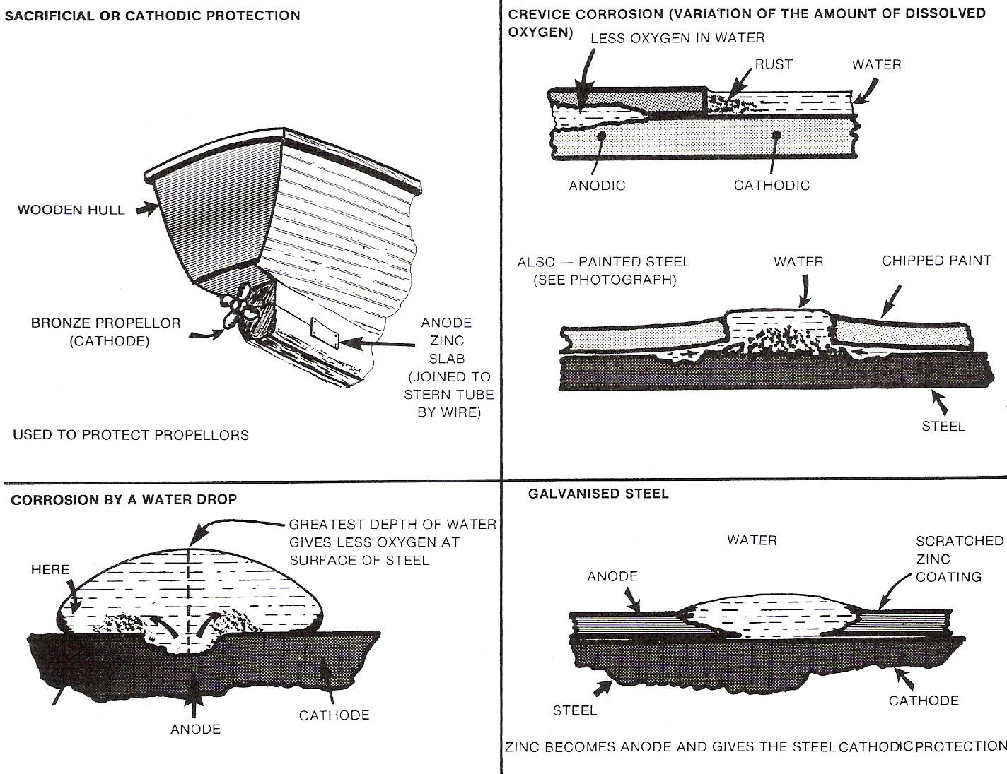
Figure 9 - Reduction

Anodising
This is an electrolytic process for increasing the thickness of the oxide film on aluminium. A hard, dense protective oxide film is produced. The thickness of the film can be controlled to suit the application of the aluminium being anodised. If the aluminium is to be exposed to the atmosphere, then a film of about 25 micrometers is used. An example is the aluminium extrusions for making windows and doors. Sulphuric acid electrolytes will give films which are good enough for indoor uses. However, special organic acid electrolytes are necessary to produce harder films, which can incorporate dyes to give the films colour. This can also be done by the sulphuric acid process, but the oxide film is not as hard.
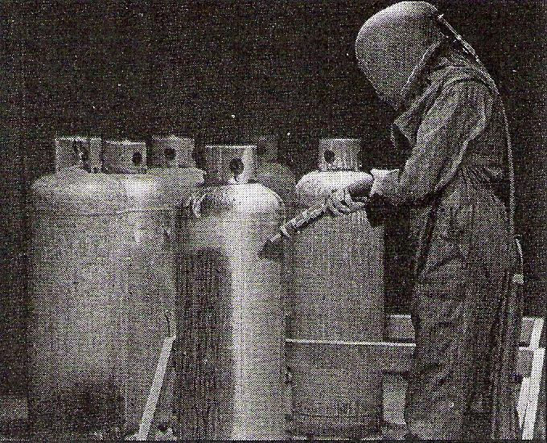
Figure 10 - Anodising

Corrosion Resistance of Steel
When chromium is added to steel, an alloy called stainless steel is formed. The chromium, which may make up 18% of the alloy, forms a protective oxide on the surface of the steel.

Protective Coatings
Protection against corrosion in the case of steel can be achieved by the application of a protective coating. This is an area where large sums of money are spent in the battle against the ‘devil rust’.

Painting
Although paint coatings are widely used to protect steel, they do not last very long and must be renewed. Many so called rust stopping paints are on the market and some are very good but only for a limited time. The best preparations contain a lot of zinc and the protection is partly sacrificial.

Hot Dipping
Here, the steel is dipped into a molten bath of the coating metal. The two most common coating metals are tin for tinplating and zinc for hot dip galvanising.
As already mentioned, the zinc gives both mechanical and cathodic protection to the steel. When the steel is immersed in the bath of molten zinc, it is left there until its temperature reaches that of the zinc. Alloys of zinc and iron form the coating which is well bonded to the steel.
For outdoor exposure, coatings of about 550 gram/m² are applied. This should give at least thirty years’ protection.

Metal Stripping
Metal coatings can be applied by metal spraying which consists of a method of melting the metal to be sprayed and blowing it onto a prepared surface (Figure 10).
A pistol-like spray unit is used which looks a bit like a paint spray gun. The metal used for the coating is fed into the back of the unit and is melted inside. Then, the molten metal is carried from the spray unit to the prepared surface by a jet of compressed air.
Heat for melting can be from an oxygen/acetylene flame or an electric arc.
As well as having wide applications in protection against corrosion, metal spraying is extensively used to reclaim worn shafts etc. (Figure 11).
Zinc and aluminium are the metals used most for spraying in anti-corrosive protection.

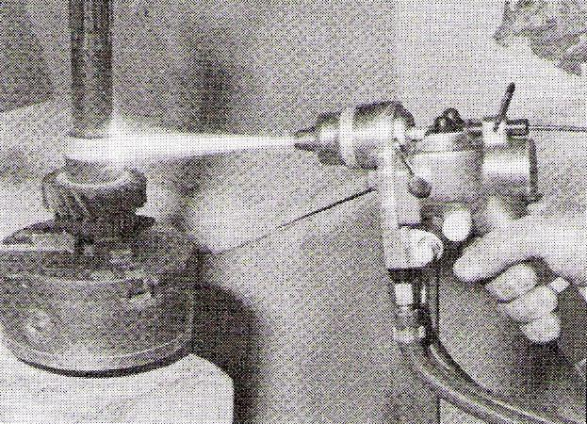
Figure 11 - Metal spraying

Electro-Plating
Electro-plating uses the chemical effect of electric current to deposit protective and/or decorative metal coatings on metal objects. The item to be 'plated' is made the cathode in a set up as shown in Fig. -13. Electrolytes containing salts of the plating metal must be used, e.g. in nickel plating, a solution of nickel sulphate can be the electrolyte.

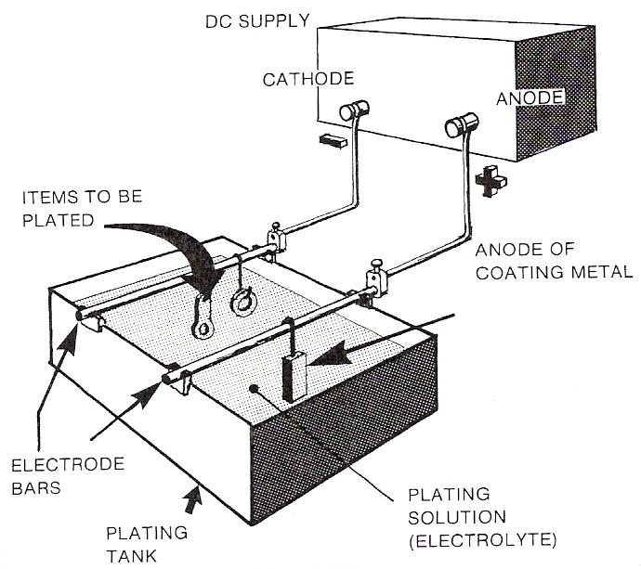
Figure 12 - Electro-Plating

Self Assessment
Questions on Background Notes – Module 3.Unit 6

- List the three main factors that will affect the Guillotine.

2. List three things necessary for Combustion to take place.

- List two types of Corrosion.

Answers to Questions 1-3. Module3.Unit 6

1.

- Rake Angle
- Relief Angle
- Blade Clearance

2.

- Fuel
- Oxygen
- Source of ignition

3.

Oxidation (Chemical Corrosion):
Metals have a chemical attraction for oxygen. When moisture is present
The metals can combine with oxygen in the atmosphere to form surface
oxides. In the case of mild steel, the oxide formed is red and is known
as rust. The process is speeded up if the atmosphere is polluted. When
sulphur bearing fuels are burned, sulphur dioxide is formed and this
contributes a lot to the corrosion of steel.

3. Continued.

Electro-Chemical Corrosion:

When two different metals e.g. copper and zinc are placed in a jar of
electrolyte (dilute sulphuric acid or salt water), an electric current will
be produced. This current is caused by electro-chemical action.

This same electro-chemical action can cause corrosion if two different
metals are touching and there is water present. The simple cell is set up
with the water acting as the electrolyte. One of the two metals will be
‘eaten’ away or corroded.

Index

C
Combustion, 17
Combustion or Burning, 17
Corrosion, 19
O
Operations on the Guillotine, 14
R
Reduction, 24
A) The, 24
Anodising, 26
B) Protection against Corrosion, 24
C) Corrosion Resistance, 24
Copper, 25
Corrosion Resistance of Steel, 26
Electro-Plating, 28
Hot Dipping, 27
Metal Stripping, 27
Painting, 26
Protective Coatings, 26
Reduction or Deoxidation, 23
S
Setting the Guillotine, 13
T
The Oxy-Acetylene Welding Flame, 17
Two Kinds of Corrosion, 19
Bright Strips on Cars, 19
Electro-Chemical Corrosion, 19
Examples of Electro-Chemical Corrosion, 19
Oxidation, 21
Oxidation (Chemical Corrosion), 19
The Rusting of Iron, 21
V
VI-Air Compressors, 8
Introduction, 8

